AMOT Israel Junior 2022 – Tournament Schedule

Managers meeting | 24/03/2022, 11:00 am
Schedule  Junior | 24/03/2022: R64 MS + all R32 + R16 XD (starting at 12h)  25/03/2022 R16 MS, WS, MD & WD (starting at 9h) + all QF (starting at 19h)  26/03/2022 all SF (starting at 10h) + all finals (starting at 13h30)  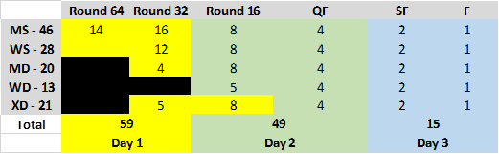
Schedule  Junior  and  Youth | 24/03/2022:  Junior: R64 MS + all R32 + R16 XD (starting at 12h)  Youth: Preliminary round (starting appx. 17:30)  25/03/2022:  Junior: R16 MS, WS, MD & WD (starting at 9h) + all QF (starting at 19h)  Youth: Preliminary round and QF (starting appx 12:30)  26/03/2022 all SF (starting at 10h) + all finals (starting at 13h30)  Youth: SF starting 09:00 + finals starting 11:30

